Explainable AI-Based Crop & Organic Pest Recommendation System
Using Soil and Dynamic Weather Data

A Major Project report submitted
in partial fulfillment of requirement for the award of degree

BACHELOR OF TECHNOLOGY
in
SCHOOL OF COMPUTER SCIENCE AND ARTIFICIAL INTELLIGENCE by
P. NEHA (2203A52168)
V. VISHISHTA (2203A52186)
K. NIKHITHA (2203A52232)
V. JANANI (2203A52185)
M. SWETHA (2203A52102)
M. AVINASH (2203A52227)

Under the guidance of

Dr. Anurodh Kumar
Assistant Professor, School of CS&AI.


SR University, Ananthsagar,Warangal,Telagnana-506371



CERTIFICATE

This is to certify that this project entitled “EXPLAINABLE AI-BASED CROP & ORGANIC PEST RECOMMENDATION SYSTEM USING SOIL AND DYNAMIC WEATHER DATA" is the bonafied work carried out by P. Neha, V. Vishishta, K. Nikhitha, V. Janani, M. Swetha, M. Avinash as a Major Project for the partial fulfillment to award the degree BACHELOR OF TECHNOLOGY in School of Computer Science and Artificial Intelligence during the academic year 2025-2026 under our guidance and Supervision.

Anurodh Kumar Dr.M.Sheshikala
Asst. Professor, Professor & Head,
SR University School of CS&AI,
Ananthasagar, Warangal SR University
Ananthasagar, Warangal.

Reviewer-1 Reviewer-2
Name: Name:
Designation: Designation:
Signature: Signature:

ACKNOWLEDGEMENT

We owe an enormous debt of gratitude to our Major project guide Dr. Anurodh Kumar, Asst.Prof, as well as Head of the School of CS&AI, Dr. M.Sheshikala, Professor for guiding us from the beginning through the end of the Capstone Project with their intellectual advices and insightful suggestions. We truly value their consistent feedback on our progress, which was always constructive and encouraging and ultimately drove us to the right direction.

We express our thanks to project co-ordinators Mr. Sallauddin Md, Asst. Prof., for their encouragement and support.

Finally, we express our thanks to all the teaching and non-teaching staff of the department for their suggestions and timely support.

INDEX

S.NO | TITLE | Page no.
 | CHAPTER-1
1 | Introduction | 1
2 | Related Work | 6
3 | Problem Statement | 13
4 | Requirement Analysis | 19
 | CHAPTER-2
5 | Proposed Solution | 25
6 | Simulation set up and Implementation | 35
 | CHAPTER-3
7 | Result Comparison | 38
8 | Learning Outcome | 41
9 | Conclusion | 43
10 | References | 44

LIST OF FIGURES

S. No. | Image Name | Page No
1 | Home Page | 08
2 | Solution Diagram | 27
3 | Architecture | 29
4 | Data Flow Diagram | 31
5 | Use Case Diagram | 33
6 | Home Page | 38
7 | User Input-1 | 39
8 | Output-1 | 39
9 | Graph-1 | 40
10 | User Input-2 | 40
11 | Output-2 | 41
12 | Graph-2 | 41

LIST OF TABLES

S. No. | Table Name | Page No
1 | Comparative analysis of existing approaches | 11
2 | Research gap indentification | 12
3 | Functional Requirements | 20
4 | Non-Functional Requirements | 21
5 | Risk Analysis | 22

ABSTRACT

In today's contemporary agricultural environment that is highly dynamic, there is a need to select the best crop based on the structure and the environment to improve the productivity and achieve sustainable production. The traditional methods of agriculture are economically relying on the historical experience and manual observation, which is not always precise in providing proper recommendations due to the changing climatic conditions. To address it, this project proposes a Machine Learning-Based Crop Recommendation System and Explainable Artificial Intelligence (XAI). The system also uses parameters associated with agriculture, such as Nitrogen (N), phosphorus (P), potassium (K), soil PH, temperature, humidity and precipitation to establish the most suitable crop to be planted. Some of the machine learning models are applied and tested to identify the optimal predictive model including the Random Forest, Decision Tree, support vector machine (SVM), Logistic Regression, and K-nearest neighbour (KNN) among others. The highest prediction accuracy of approximately 87 percent was experienced with the Random Forest classifier among others and it demonstrates an excellent performance in the agricultural data classification process. Explainable AI is presented in the introduction of the system to enhance transparency and the confidence of a user with the assistance of the LIME technique which describes the most important factors that underlie the recommendation of each crop. In addition, the system also relates to real-time weather data as the OpenWeather API and is developed based on a web interface with Flask, providing farmers with a simple way to add environmental parameters to the system and receive real-time recommendations. The advantage of this combined solution is that it improves the quality of the decision-making, the quality of agricultural performance and the use of the data-driven precision farming. It is possible to improve in the future with the addition of incorporation into larger data sets, the application of the IoT connected soil sensors and the execution of the application on a mobile platform which might be more convenient.

ABOUT THE ORGANIZATION

SR University is a top-rated university in India among the private universities that are determined to excel in the spheres of education, research, and innovation. It offers a transformative learning process that promotes new ideas among the students, sophisticated technical competence and a contribution to the society. Having an intensive emphasis on outcome-based education, the university facilitates creativity, entrepreneurship and lifelong learning. The School of Computer Science and Artificial Intelligence is one of its different academic schools that primarily provides courses in the new technologies including Artificial Intelligence (AI), Machine Learning (ML), Data Science, Cloud Computing, and the Internet of Things (IoT). The campus has the best infrastructure, the latest computing facilities, and the latest research tools which facilitate the project-based learning and academic excellence.
Computer science and engineering department of SR University is encouraging students to engage in problem solving through research based work and real world. The members of the faculty are actively involved in mentoring the students to discover advanced technologies that can become forces of innovation in various fields. Through cultivating technical talent and encouraging learning that focuses on innovation, SR University remains empowering its students to become global competent professionals and responsible innovators who will be able to make a significant contribution to the world.

CHAPTER-1
1.1 INTROCUCTION
In the today's modern fast changing agricultural setting, enhancement of crop yield, and sustainable farm production has become a significant issue among farmers. The common traditional methods of farming are based on some previous experience or manual observation or generalized farming practices, this will not always be accurate in crop choice because of the changes in the nutrients of the soil, the climate conditions and the environment. Planting the wrong crop may lead to poor production, losses and wastage of resources. The increasing problem underscores the need to have a smart and automated mechanism that can help farmers to choose the most appropriate crops in accordance with the scientific data and environmental factors.
The proposed Crop Recommendation System based on Machine Learning is paired with Explainable Artificial Intelligence (XAI) to minimize this difficulty by incorporating both the advanced machine learning tools and the explanation models of artificial intelligence. The system examines significant parameters of agriculture including Nitrogen (N), Phosphorus (P), Potassium (K), soil pH, temperature, humidity, and rainfall in order to identify the most appropriate crop to be grown. Among the machine learning algorithms, there are Random Forest, Decision Tree, Support Vector Machine (SVM), Logistic Regression and K-Nearest Neighbor (KNN) designed to gather the patterns in agricultural data and predict the viability of crops with high accuracy.
The suggested system is based on the modular architecture that comprises several steps such as data collection, preprocessing, machine learning prediction, and explainable AI analysis. The machine learning models compare the input parameters and determine the best crop in the prevailing environmental conditions. The model that was best performed was the Random Forest model which is accurate and reliable in giving crop recommendations.
In order to enhance more transparency and trust in the system, Explainable AI with the help of the LIME technique is incorporated, which underlines the most significant features that contribute to every prediction. This enables the users to know the reasoning behind the recommendation of a given crop thus making the system easier to interpret and rely on.
The system has been implemented with the help of Flask-based web application that allows farmers to simply input soil and environmental data and obtain instant crop guidance. The proposed system will enable the use of data to make informed decisions in agriculture by using smart forecasting and providing explainable insights, increasing crop production, and encouraging the use of the modern method of precision farming. This system does not substitute the expertise of farmers, but instead improves their decision-making capacity and assists in making sure that agricultural practices would be more efficient and sustainable.
    - OBJECTIVES OF THE PROJECT
The primary goal of the Crop Recommendation System based on the principles of the Machine Learning and Explainable Artificial Intelligence (XAI) is the creation of a smart and user-friendly service that will help farmers choose the most appropriate crop according to the soil and environmental factors. Agriculture generates extensive data amounts of soil fertility, climate, and precipitation and yields. Nonetheless, farmers are usually in a disadvantageous position of deciphering such information when making decisions regarding the cultivation of crops. Consequently, this project will help to turn raw data of the agricultural field into valuable information by applying machine learning methods and provide the farmers with the opportunity to make reasonable and data-driven decisions by means of a simple web-based application.
The other key aim of the project is to offer an easy to use interface that will enable farmers or users in the agricultural sector to easily input the soil and environmental values including Nitrogen (N), Phosphorus (P), Potassium (K), soil pH, temperature, humidity and rainfall. Once such inputs have been keyed in the system analyzes the data and provides the most appropriate crop to be cultivated. This is a process of interaction that is very straightforward, as even the users who have the least standards of technical knowledge can easily navigate through the platform and receive the reliable recommendations on agricultural planning.
Another aspect of the project is the implementation of several machine learning algorithms like the Random Forest, Decision Tree, Support Vector Machine (SVM), Logistic Regression, and K-Nearest Neighbor (KNN) to process agricultural data and find some patterns that determine crop growth. The system uses the performance of these models to choose the most precise algorithm in predicting crop recommendations. This means of analysis enhances the reliability of prediction and the farmers get scientifically tested recommendations.
The other important goal of the project is to incorporate the Explainable Artificial Intelligence (XAI) through the LIME method. This aspect will assist users in knowing the reasons behind any specific crop by displaying the most relevant factors that influence the prediction. Rather than just delivering the final outcome, the system justifies the rationale of the suggestion, which enhances the transparency, trust, and comprehension of machine learning choices.
It is also the goal of the project to integrate in real-time environmental awareness with the integration of weather information by an external weather API. This integration would aid the system to take into account current environmental conditions when making a recommendation, which enhances the applicability and realism of the predictions. The system assists in making better agricultural decisions by providing parameterized soil data with climatic data.Last but not least, the project will construct a scalable and extensible agricultural support system which can be expanded in future. Other functionalities like mobile apps support, connecting with IoT based soil sensors, suggestion of fertilizer, and historical crop analysis can be added in the future. Using a modular architecture and the latest web technologies in the design of the system, it is possible to transform the platform into the complex of smart agriculture that would allow promoting sustainable agriculture and boosting the productivity of farmers.
    - SCOPE OF THE PROJECT
The primary objective of Crop Recommendation System based on Machine Learning with Explainable Artificial Intelligence (XAI) is to create a platform that can be used by farmers to choose the most appropriate crop to grow, depending on the nutrients on the soil and the environment. The agricultural purposes produce vast quantities of data, including the composition of soils, temperatures, humidity, and rainfall data, as well as crop productivity data. Nevertheless, this information is normally hard to access to farmers as it is always brought out in complex data sets or agricultural reports. Thus, the purpose of this project will be the conversion of raw agricultural data to useful recommendations that are easily interpreted by farmers using a simple web-based system.
The other significant area of the project is the easy and accessible agricultural decision-making among the farmers. The system gives users the opportunity to input significant soil and environmental factors including Nitrogen (N), Phosphorus (P), Potassium (K), soil pH, temperature, humidity and precipitation. Considering such inputs, the system processes the data with the help of machine learning models and proposes the most appropriate crop to be cultivated. It is a simple interaction process that makes the system user-friendly even when it is being used by farmers who might not possess advanced technical expertise.
Another aspect of the project is to enhance knowledge on crop recommendations using methods of visualization. The system can also show model performance comparison, prediction outcomes, and feature significance in the form of graphical display, like charts and graphs instead of simply showing the results in text. These visualizations allow users to determine the factors that affect crop recommendations and performance of various machine learning models easily.
The other valuable feature of the project scope is the integration of Explainable Artificial Intelligence (XAI). The system has the LIME technique to explain the reason behind the recommendation of a given crop showing the important factors involved in the prediction. This enhances transparency and makes the farmers have confidence in the recommendations that the machine learning system will produce.
Modern digital agriculture methods are also justified within the project whereby a web-based system developed using Flask is implemented so that farmers may access the system via a simple interface. The system is realistic and useful in making agricultural decisions in the real world by providing users with crop advice immediately they enter soil and climate data
Lastly, the project is built with a scalable and extendable construction, which enables its enhancement in the future, e.g., the integration with the IoT-based soil sensors, fertilizer recommendation modules, pest detection modules, and mobile applications. With the help of contemporary machine learning and web technologies, the system will be able to become a multi-faceted smart farming solution that will enhance the yield of agriculture and promote sustainable farming.
1.1.3 IMPORTANCE OF THE PROJECT
The Explainable Artificial Intelligence (XAI)-based Crop Recommendation System using the support of the Machine Learning is a influential technological tool that can be used to serve contemporary agriculture by determining the most appropriate option of the crop selection in the farmers. Agriculture generates huge amounts of data in the form of nutrients of the soil, climatic conditions, rainfall patterns and crop productivity. This information, though, may always be hidden in different sources and presented in a complicated array of information that cannot be easily comprehended by the farmers. The proposed project will address this issue by coding agricultural information into a properly arranged system that could analyze the soil and the environment and provide clear crop advice depending on available web-based platform.

Some of the key importance of the project include the fact that it would help the farmers to make empirical decisions regarding crop farming. By analyzing the important parameters on the environment such as Nitrogen (N), Phosphorus (P), Potassium (K), soil pH, temperature, humidity and rainfall, the system is able to identify the most suitable crops in a specific environment. This will reduce the chances of farmers embracing wrong crops that can create low yield, losses and wastages of resources such as water and fertilisers.

The second applicable significance of the project is that the project incorporates the use of machine learning algorithms to improve the accuracy of crop suggestions. The system uses random Forest, Decision tree, Support Vectors Machine (SVM), Logistic regression and K -Nearest Neighbor (KNN) models in analyzing agricultural data and identifying patterns that influence the growth of crops. These intelligent algorithms would help to produce valid predictions and overall improve the work of the agricultural planning.
Also a part of the project is transparency in machine learning predictions with emphasis on Explainable Artificial Intelligence (XAI). The system describes the factors which determine every crop suggestion through techniques such as LIME. This gives the farmers more confidence in the system and the technology more realistic in real-world application in agriculture as farmers are informed of the reason behind proposing a particular crop.
The other important characteristic of the system is convenient access web-interface that has been developed based on the existing web technologies. The farmers or other users of agriculture can easily enter soil and environmental data and access recommendations on crops immediately. This not only eases the decision making process of agriculture but also provides some sophisticated technologies even in the reach of those who are not that technologically advanced.

Finally, the project demonstrates the possible practical application of machine learning and data analytics in the field of agriculture that promotes the utilization of smart digital tools to farm. It also enables the application of precision agriculture whereby information-based knowledge is applied to improve the productivity, efficiency, and sustainability of crops. Another way the system can be used in future extensions, such as integration with soil sensors (IoT), fertilizer prescriptions, mobile applications and real time monitoring of agricultural systems, is via the system, though it is applicable as a solution to the creation of smart farming technologies.
  - RELATED WORK
Several studies and systems are developed to aid in the agricultural decision-making processes depending on the data analysis and machine learning techniques. Traditional farming practices mainly hinge on experience of the farmers, past pattern of crops and general laws of farming to decide on the type of crop that would be produced. Information about the crops, soil conditions and weather related information are also available in government websites and the agricultural advisory portals but these portals typically show the information in their original forms, e.g. reports, tables or generic advice. Farmers therefore will not be in a position to process this information quickly and make good selections on their crops.

In the past few years, researchers have talked about the possibility of improving crop recommendation systems with the help of machine learning and data analytics. Some algorithms include random Forest, Decision Tree, Support Vector machine and Neural Networks which have been applied in numerous researches to check the parameters of agriculture such as soil nutrients, pH levels, temperature, humidity and rainfall. The models can help in identifying the trend that exist between the elements in the environment and the crop productivity and a very smart system can be made to determine the appropriate crop upon analyzing data.
Several research studies have also incorporated data visualization in order to present the farming insights in a more superior way. Visualization tool represented in the form of charts, graph and performance comparison dash boards allow the user to understand the data between the soil parameters and crop growth. These graphic presentations allow researchers and farmers to interpret complex data sets and estimate model performance.
Artificial Intelligence and decision support systems have also started to find application in other newer uses in agriculture to predict crop growth and give intelligent advice. However, the majority of the provided systems are more focused on the quality of forecasting and do not show how the recommendations are received in a clear way. This is because such predictions made by machine learning may result in reduced confidence of the system by the users and actual practical implementation of machine learning.
The proposed Crop Recommendation System that implies the usage of the machine learning and the Explainable Artificial Intelligence (XAI) is founded on these existing approaches and enhanced by the integration of a series of machine learning models, explainable AI algorithms, and intuitive web interface in the same platform. Unlike the classical model of agricultural advisory, the specified project not only forecasts the most suitable crop but also understands the main causes of the specified recommendation using explicable techniques of AI. This integrated system improves transparency, usability and decision making in that farmers are better placed to make an insight on crops based on outcomes of the soil and environmental requirements.
INTRODUCTION
Agriculture is a crucial aspect of the economy and food production of most countries particularly in countries such as India whereby a big percentage of the population uses agriculture as a source of livelihood. The decision of the crops to be grown depending on the soil and environmental conditions is one of the most crucial choices farmers have to make. Each farming season produces voluminous data in terms of soil nutrient levels, temperature, humidity, rainfall pattern and crop performance data.
Data on this is usually contained in farm reports, datasets or research papers. Nevertheless, this information can be useful although it may be hard to interpret by farmers, students, and researchers due to the fact that much of it is normally formatted in complex formats and massive data. Conventional methods of farming are largely based on experience or broad agricultural principles and not on scientific evidence. This has made farmers at times forget that some crops do not suit their soils and climatic conditions and therefore end up producing low yields at the cost of losses.
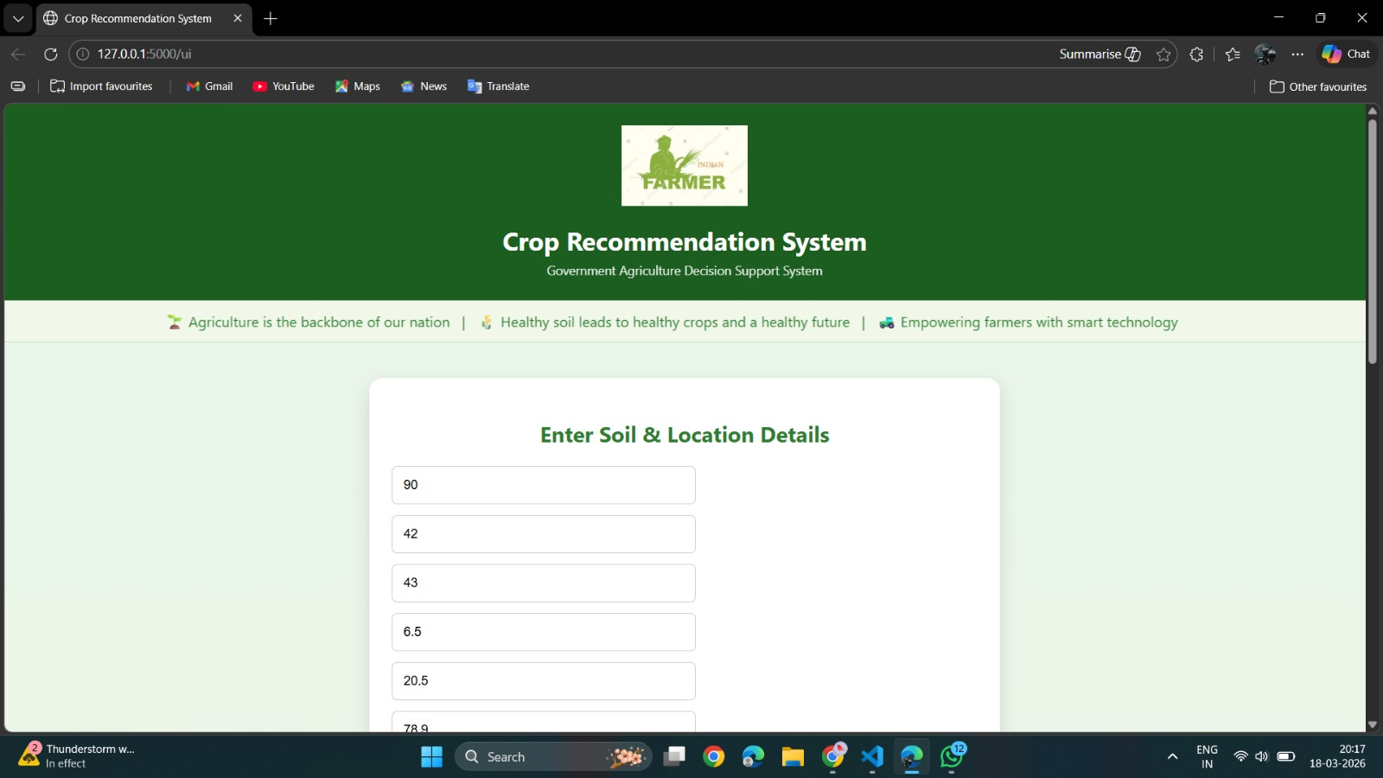Fig1: Home Page
As the sphere of technology evolves rapidly, the use of data analysis and machine learning methods in the agricultural domain and enhancing decision-making is becoming increasingly popular. The large agricultural data sets can be analyzed using intelligent systems and patterns that may be used to determine which crops thrive better than other crops under certain environmental conditions. Nevertheless, most of the traditional systems are capable of giving predictions alone without clearly outlining the manner in which these recommendations are arrived at a phenomenon that may diminish the level of trust of the users.
To solve these problems, the Crop Recommendation System based on the concept of Machine Learning and Explainable Artificial Intelligence (XAI) is created to work with data collected on farms and offer appropriate recommendations on crops to grow. The system employs machine learning algorithms to examine soil nutrients; Nitrogen (N), Phosphorus (P), Potassium (K), soil pH, and temperature, humidity and rain fall. The system can integrate machine learning, data analysis and explainable AI to assist the farmers and users to quickly know which crops best suit their land conditions.
The proposed system will convert the complicated agricultural data to simple and clear-cut recommendations through smart analysis and a user-friendly interface. Such a practice will help enhance the agricultural planning process, stimulate their productivity, and promote the utilization of modern data-driven farming practices.
    - Existing Systems and limitations.

Currently, agricultural portals, agricultural advisory websites, research publications, as well as agricultural reports are the main source of most agricultural information and crop recommendations. Such sites tend to render details regarding the health of soil, cultivating instructions, climate, and other farming techniques. Farmers mostly rely on the agricultural specialists, manuals or traditional farming knowledge to determine the type of crop to be grown. Though these sources are helpful they are usually displayed in the form of reports, documents or in static forms that might be hard to interpret and use directly to their fields by the farmers.

Agricultural officers or local specialists in farming are also another method of approach that is commonly applied in agriculture. Although this approach can offer viable recommendations, it might not necessarily involve the analysis of detailed data of the soil nutrients, environmental parameters, or live climatic conditions. Also, these recommendations can be different, depending on the presence of experts, and can not necessarily offer similarly reliable or data-driven recommendations.

Analysis Data analysis tools and programming languages like Python or statistical platforms are also applicable to researchers and agricultural analysts to analyze crop patterns, soil nutrients, and environmental factors influencing crop growth. Such analytical tools have got the capacity to give precise predictions and insights but they need technical knowledge and skills in analyzing data. Consequently, these systems are not easily accessible by most farmers and general users to do the complicated agricultural data analysis by themselves.

Although these systems are available, they have a number of limitations. The key weakness is that there are no smart and automated crop recommendation technologies that can study the soil and environmental situation in real-time. Most of the available platforms do not offer specific recommendations but general crop guidelines in accordance with specific field conditions. The lack of interactive analysis and visualization is another weakness as it is hard to see patterns and relationship between parameters of soils and crop suitability.

Moreover, not all traditional systems are explainable and have transparency in the way, in which the recommendations are generated. It is also common in the systems, even with machine learning models, to give predictions, but not to explain factors that influenced the decision. This may decrease user confidence and restrain the use of such technologies by the farmers.

In the attempt to address these shortcomings, the proposed Crop Recommendation System based on Machine Learning with Explainable Artificial Intelligence (XAI) will combine both agricultural data analysis and machine learning prediction with explainable AI into a single platform. The system examines the nutrients of the soil and other environmental parameters to prescribe the apt crops and even gives clear explanations of the factors that will affect the predictions. Such a combined strategy enhances accessibility, transparency, and decision-making, which allows farmers to learn more about the suitability of crops and implement modern data-based farming strategies.

1.2.4 COMPARATIVE ANALYSIS OF EXISTING APPROACHES

Approach / System | Description | Advantages | Limitations
Traditional Farming Methods | Farmers select crops based on experience, seasonal patterns, and general knowledge. | Simple and does not require technology. Based on practical field experience. | May lead to incorrect crop selection due to lack of scientific analysis and changing environmental conditions.
Agricultural Advisory Systems | Government or private platforms provide general crop suggestions based on region and season. | Provides basic guidance and awareness to farmers. | Not personalized according to soil nutrients and real-time conditions. Limited accuracy.
Soil Testing Reports | Laboratories provide soil nutrient data such as N, P, K values and pH levels in report format. | Provides accurate soil information for decision-making. | Difficult for farmers to interpret reports and decide suitable crops without expert help.
Proposed Crop Recommendation System | A web-based system that uses machine learning and XAI to recommend crops based on soil and environmental parameters. | Provides accurate predictions, user-friendly interface, and explanation of results using XAI. | Requires proper dataset quality, regular updates, and model maintenance for best performance.

Table 1: COMPARATIVE ANALYSIS OF EXISTING APPROACHES

Overall, the comparative analysis shows that while existing systems provide valuable election information, they lack integration of visualization, interactivity, and intelligent assistance. The proposed system addresses these limitations by offering a unified platform that improves accessibility, simplifies data interpretation, and enhances user engagement through modern analytical tools.

1.2.5 Research gap identification

Currently the crop recommendation systems are primarily concerned with the prediction of appropriate crops but they are not a complete solution to the farmers. Most of the models do not incorporate real time weather information, which influences accuracy in prediction. Also, the results provided by most systems are not explainable and thus users fail to comprehend why a certain crop is recommended. It also has a less accent on offering organic pest control recommendations because most of the methods in use only focus on crop forecasts. Moreover, a few of the systems can be used by only the soil data without paying attention to the environment, and they are not always user-friendly so that farmers cannot use them.

Existing System / Approach | Current Features | Identified Research Gap | Proposed Solution
Traditional Farming Methods | Crop selection based on farmer experience and general knowledge | Lack of data-driven decision making and accuracy | Provide ML-based crop recommendations using soil and climate data
Agricultural Advisory Websites | Provide general crop suggestions and guidelines | Not personalized based on real-time soil parameters | Develop system that gives customized recommendations based on user input
Manual Soil Testing Reports | Provide soil nutrient values in report format | Difficult for farmers to interpret and decide suitable crops | Convert soil data into clear crop recommendations using ML
Data Science Tools | Provide advanced analysis using ML models | Require technical knowledge and programming skills | Build user-friendly interface accessible to non-technical users
Separate Agricultural Data Sources | Data available from different platforms (weather, soil, crops) | Lack of integration and unified analysis | Create a single integrated platform combining all parameters for prediction

Table 2: Research gap identification

  - PROBLEM STATEMENT

Agriculture is a key factor in food security and economy of a country particularly in countries such as India where it is an important source of livelihood to a large percentage of the population. The biggest problem that farmers encounter is the selection of the most suitable crop depending on the soil nutrients, environmental factors and climatic conditions. Farmers in most instances use traditional knowledge, past experiences or general assumptions in making decisions regarding the types of crops to grow. This traditional methods, however, might not produce the best yield of crops always because there are varying climate conditions, variability of soil, and uncertainty of rainfall levels.

When there are no proper and factual decision support mechanisms, then chances are that farmers will be planting inappropriate products on their farms. This may result in low productivity, wastage of resources like water and fertilizers and loss of money. Also, the available agricultural advisory systems have not been integrated with real-time data and do not provide transparency in the manner in which the recommendations are being developed hence the farmers cannot trust or even understand the recommendations given to them by the advisory systems.

Moreover, the vast majority of conventional crop recommendations approaches fail to harness the capabilities of the latest technologies including machine learning and explainable AI. In the absence of smart examination of soil fertility content such as Nitrogen (N), Phosphorus (P), Potassium (K), soil pH, temperature, humidity, and rainfall, it becomes hard to find out the most appropriate crop to be planted in a given area.

This project suggests a Crop Recommendation System through the application of Machine Learning and Explainable Artificial Intelligence (XAI) to handle these issues. The system examines the parameters of the agriculture and applies the advanced machine-learning algorithms to prescribe the most appropriate crop. Furthermore, explainable AI methods are also added, to offer clarity into the decision-making process and to allow farmers to see the logic behind every suggestion and to empower more coherent and refined agricultural activities.

    - STATEMENT OF THE PROBLEM

Agriculture produces a mass of information connected with soil nutrients, climatic conditions, rains, and yield of crops. This knowledge helps the farmers to determine the crops that are best to cultivate. This data is however mostly found in the form of agricultural report, research papers or government advisory documents which are mostly prepared in a complex tabular, dataset or long document format. These formats do not enable easy interpretation of the information by farmers and the general users and consequently, effective application in their farming efforts.

The current agricultural information systems are primarily designed to offer general crop guidelines/soil reports as opposed to intelligent systems that can assist the farmers analyze the data and make good decisions on the crop selection. Traditional knowledge, experience or recommendation of agricultural experts often guide the decision made by farmers on which crops to produce. Although these approaches can be quite useful, they are not always directed to detailed data analysis of the soil nutrients and environmental conditions that can result in wrong selection of crops and low level of agricultural production.

A second significant issue is that many agricultural advisory systems do not have interactive and analytical tools. The majority of platforms are presented in the form of text or tables and lack any form of graphics or forecasting. The farmers cannot detect the trends in the relationship between the soil conditions, weather parameters, and crop aptitude without proper analysis and visualization.

In addition, most of the available systems lack intelligent machine learning models capable of automatically computing agricultural parameters and making valid recommendations on crops. The various factors that need to be analyzed by the users include Nitrogen (N), Phosphorus (P), Potassium (K), soil pH, temperature, humidity and rainfall which are all determined manually by the users to determine the crop to be grown. This may be a lengthy and challenging process to the farmers who might lack technical skills in data analysis.

Thus, the research question that this project will focus on is the fact that an effective and automated crop suggestion system is required to analyze agricultural information and give valid crop suggestions. It is proposed to address this issue with the proposed Crop Recommendation System based on Machine Learning with Explainable Artificial Intelligence (XAI), which will result in the creation of a web-based system that combines the agricultural data, machine learning prediction models, and explainable AI methods. The system allows farmers to enter soil, environmental parameters easily and get effective and reliable crop recommendations and explanations on how to make improved and informed decisions about agriculture.

    - NEED FOR THE STUDY

Farming contributes to the economy and food security of most of the countries especially in India where most of the population relies on farming as their means of livelihood. Farmers have to determine crucial choices in terms of the choice of crops according to the fertility of the area, weather conditions, and environmental factors. Each farming season produces the massive data connected with the nutrients of soils, temperature, rain, humidity, and yield of crops. Though such information is accessible against some of the conventional sources such as agricultural reports, research studies and government advisory portals, they are usually interpreted and displayed in intricate datasets or technical formats, which farmers and common users find challenging to comprehend and interpret.

This study is necessary due to the growing significance of data-driven decision making in the agricultural sector. The conventional methods of farming mostly depend on experience, hand observation, or general rules of farming but not the analysis of scientific data. Consequently, this may cause farmers to at times plant crops that do not fit the soil or climate conditions, hence, resulting into low yields and losses. Thus, there is an enormous demand in smart systems that can process the data on agriculture and give the right crop recommendations.

The rising application of information technologies and web-based applications in gaining access to agricultural information is also another significant cause of this study. Interactive systems that can deliver quick and comprehensible insights are preferred by the modern users compared to a stagnant report or document. With the use of visualization tools and machine learning, agricultural data can be converted to valuable recommendations that are readily understandable and applicable in the actual farming context by farmers.

Moreover, machine learning and explainable artificial intelligence (XAI) can be used to enhance the reliability and transparency of crop recommendation systems. The system can also indicate the causes of a specific recommendation such as the nutrient content of the soil, the soil pH content, temperature and rainfall to the client instead of merely forecasting an appropriate crop. This would assist the users to know how the decision was arrived and they will be more confident using the system.
This research paper, thus, aims at creating a Crop Recommendation System with Machine Learning and Explainable Artificial Intelligence to transform complex farm data into simple and meaningful information. The system should facilitate farmers, students, and researchers with a simple-to-use platform enabling them to analyze the soil and the environmental conditions and make more informed decisions regarding the choice of crops. The proposed system helps in the efficient and sustainable farming by enhancing accessibility, accuracy and transparency in the agricultural data analysis.

1.3.3 STUDY GOALS

This paper is dedicated to the creation of an intelligent Crop Recommendation System based on Machine Learning and Explainable Artificial Intelligence (XAI) to help farmers and other users of the agricultural industry to choose appropriate crops depending on the condition of the soil and the environment. The primary focus of the study lies in the analysis of the agricultural data that cover some parameters that are soil nutrients (Nitrogen, Phosphorus, Potassium), soil pH level, temperature, humidity, and rainfall. These parameters are handled in the system to give recommendations on the crops that best fit the conditions.

The other factor that can be discussed within the framework of the present project is the application of machine learning algorithms (Random Forest, Decision Tree, Logistic Regression, K-Nearest Neighbors (KNN) and Support Vector Machine (SVM). The dataset is analyzed using these models and predictions of the most fitting crop is made based on the input parameters. The performance of these models is also compared in the system to determine which algorithm has the highest prediction accuracy with regards to crop recommendation.

Along with data visualization and user-friendly web interfaces are also part of the study in order to simplify results to understanding. The system would be a web-based system whereby users would enter the soil and environmental parameters and get the crop recommendations immediately. These visualization tools like charts and graphs can be used to make users comprehend the effect of various parameters on crop selection.

The introduction of Explainable Artificial Intelligence (XAI) methodologies, including LIME that allows explaining the way the machine learning model arrives at the recommendations, is another significant aspect of the project. This aspect enhances transparency and user confidence due to the ability of the process to demonstrate the key factors that contributed to the prediction of crops.

Nevertheless, the study is only restricted to the analysis of available agricultural datasets and the recommendations of crops given the parameters. The system does not operate directly on farming operations and does not substitute the farming professionals. Rather, it is a decision support tool that can enable farmers, students and researchers to make decisions about the selection of crops through intelligent analysis and easier user interaction.

    - STUDY SCOPE

The major aim of this study is to establish a smart and viable system, which would help the users identify the most agreeable crops based on the environmental and soil factors. Agriculture takes note of much data such as soil nutrient level, temperature, humidity, precipitation, pH level. However, even the farmers and the agricultural planners have difficulties in analyzing such data and make decisions on the crop that will yield the best results. In this way, the suggested research will develop a system that will convert the raw agricultural data into meaningful crop advice using machine learning and explainable artificial intelligence.

The other way through which the study would be significant is the improved availability of the agricultural decision-making tools to different classes of users such as farmers, agricultural researchers and students. The system is coded in such a way that it has a user-friendly interface whereby a user can simply feed the subsequent parameters, nitrogen, phosphorus, potassium, soil pH, temperature, humidity and rain fall. The system will take the data on these inputs and process it to provide the best crop to grow.

This is a systematic approach that enables one to obtain useful hints within a very minimal time without technical knowledge.
The other goal of the study is to integrate data visualization and analysis tools so as to improve the understanding of the process of crop recommendations. The information can be displayed in the system in the form of the graphs such as charts and visualization of the importance of features. The visual tools ensure that users can calculate how different environmental aspects influence the selection of crops and provide the user with a better perspective of the information about agriculture that is being analyzed.

The other goal of the study is to unify the Explainable Artificial Intelligence (XAI) systems such that the machine learning recommendations would be more transparent and understandable. Techniques such as LIME are used to narrate the process by which the model arrived at a particular recommendation of crop and the most influential input parameters that were used. This enhances confidence of the users on the system and makes it easy to interpret the predictions.

Finally, the study will also benefit in the creation of scalable and flexible platform that can be expandable in future. The system will be built in the modular architecture, and then it will be possible to introduce new features such as predicting the yield, weather-based recommendations, and real-time connection to the agricultural data in the future. With these purposes, the project contributes to the improvement of information-based agriculture and supports farmers to make more appropriate decisions regarding the kind of crop to be planted in order to increase the productivity.

1.4 REQUIREMENT ANALYSIS:
Requirement analysis is a significant stage in the development of the system in which the specifications of the users and the system capabilities are specified. The requirement analysis in the case of the Crop Recommendation System with the use of the Machine Learning can assist with understanding what features the system needs to offer, how people will communicate with the system, and what technologies will be needed to implement it. Its primary goal is to convert raw agricultural data into an intelligent and interactive system that would enable users to use appropriate crops depending on the soil and environmental parameters.

The system to be proposed will offer a simple, systematic method of inputting the parameters of agriculture, including nitrogen, phosphorus, potassium, temperature, humidity, rainfall, and soil pH to the system. Any given set of inputs makes the system run the data on machine learning algorithms to produce precise crop suggestions. The system must be in a position to input validation, manipulate the data and present the results in a transcible manner to the user.

The machine learning and explainable AI (XAI) techniques are another important demand of the system. The system should not just tell what the appropriate crop is but also how such prediction has been achieved. This enhances transparency and makes users know the significance of various parameters in crop selection.
The user friendly interface should also be part of the system where the interaction between the system and both the technical and the non technical users particularly the farmers should be easy. It should be easy, understandable, and quick to use as the interface allows users to enter the inputs and see the results without any problem.
Moreover, the system should be able to provide performance, reliability and security. It must also be capable of responding fast, staying true to predictions as well as dealing with user data with security. The system must also be expandable in order to add new datasets or new functions in future.
In general, requirement analysis will make sure that the Crop Recommendation System is developed in a systematic way, addresses client demands, and is capable of transforming agricultural data into valuable crop recommendations with the help of machine learning and XAI systems.

Functional Requirements:
The functional requirements elucidate the key activities that the system must undertake to achieve its objectives. These requirements are manifested in the Crop Recommendation System and they state how the system relates with the users and interprets the agricultural data to generate beneficial outputs. The system should also allow the user to type important parameters in agricultural fields such as nitrogen, phosphorus, potassium, temperature, humidity, rainfall, and soil pH through an interactive system. After receiving such inputs, the system will then be able to run the data using machine learning algorithms to analyze patterns and relationships in the dataset.

The system should be capable of generating the right crop suggestions in consideration of the values of the input. In addition to prediction the system must also provide the explanations of the proposed crop with the assistance of Explainable AI (XAI) processes so that users can know how different factors could lead to the result. This system is expected to provide the output in a simple and understandable format that would lead to the ease with which the users including the farmers and other non-technical people will be able to interpret the recommendation. it should also validate the user entries and the inaccuracy in which correct messages are displayed whenever wrong or missing information is entered.
Finally, the system should also be in a manner that the frontend and the backend are linked, and the requests made by the users can be handled effectively and the outputs delivered on time.

Requirement Type | Description
Input Handling | The system is to enable users to key in agricultural parameters like nitrogen, phosphorus, potassium, temperature, humidity, rainfall, and pH of the soil.
Data Processing | The machine learning algorithms should be able to analyse patterns by processing input data.
Prediction | There must be the ability to create precise crop recommendations according to user inputs by the system.
Explanation (XAI) | Explainable AI techniques should be used to give explanations for the predicted crop in the system.
User Interface | The results should be presented in the system in a clear and uncomplicated format.

Table 3: functional requirements
Non-Functional Requirements:

Non-functional requirements are the features of the system in terms of qualities and performance which are not functional. The requirements will ensure the effectiveness, reliability and security of Crop Recommendation System and ensure it has good user experience.It is also expected to be highly fast i.e. the system should be capable of accepting input by the user and giving recommendations about a crop in real-time without any noticeable lag. This has to be user-friendly and it should be made in a manner where it is easy to use with an understandable, straight forward and simple interface, which enables the ease of access of the system by farmers and non-technical users.
The system should be reliable by providing accurate crop recommendations when given the data required as well as reliability in the sense that the system will not need regular error and breakdown. It should also be properly secured, by making sure that user entries are checked and it is not applied in a false manner and wrong interpretation of information

Requirement Type | Description
Performance | The system should retrieve and display election results quickly without noticeable delay.
Usability | The interface will be user friendly and easy to use by non-technical and technical users especially farmers.
Reliability | The system should be able to give proper recommendations on crops and be stable in performance.
Security | Data that is being inputted by users should be treated with care to avoid misuse or wrong processing.
Scalability | The system must also be able to handle more of the agricultural data sets and other future develops such as sophisticated analytics or prediction algorithms.

Table 4: non-functional requirements

The system should also be expandable with additional agricultural data, improved machine learning algorithm, or other capabilities can be included into the system in the future without affecting performance. On the whole, these non-functional requirements are certain to ensure that the system is efficient, smooth and reliable in terms of user experience.

1.4.1 RISK ANALYSIS:

Risk Type | Description | Possible Impact | Mitigation Strategy
Data Risk | Incomplete or inconsistent agricultural datasets | Incorrect crop recommendations | Perform data cleaning, validation, and preprocessing
Technical Risk | Errors in ML model, backend APIs, or integration issues | System malfunction or wrong prediction results | Regular testing, debugging, and model validation
Performance Risk | Slow processing of large datasets or model computations | Delay in generating crop recommendations | Optimize algorithms and use efficient data processing methods
Security Risk | Improper handling of user input data | System misuse or incorrect input affecting results | Implement input validation and secure backend processing
Usability Risk | Complex interface may be difficult for farmers to use | Reduced user satisfaction and adoption | Design simple, user-friendly interface with clear inputs
Table 5: Risk analysis

Overall, effective risk analysis helps ensure that potential issues are identified and addressed during the development process. By implementing proper data validation, system optimization, and security measures, the AI Election Analysis platform can maintain reliable performance and deliver accurate insights to users.

1.4.2 FEASIBILITY ANALYSIS:

The feasibility analysis is a significant phase in project development that assists in concluding whether the planned system can be implemented successfully with the help of the resources, technology, and time accessible. It considers various aspects including technical ability, economic price, operational usability, project schedule and so on. In the example of the Crop Recommendation System based on the Machine Learning, the feasibility analysis guarantees the ability to process agricultural data by the system, provide correct crop suggestions, and operate on an easy-to-use platform by the farmers and researchers.

The proposed system has an opportunity to be realized technically since it is based on the widely used technologies like HTML, CSS, and JavaScript to create the frontend interface and Python and such frameworks as Flask to process the data on the backend. These technologies are beneficial in the making of an interactive web site where individuals can input key agricultural parameters that include nitrogen phosphorus, potassium, temperature, humidity, rainfall and soil pH. All these inputs are computed in the backend, with machine learning algorithms to forecast the most appropriate crop to grow. Python packages, including Pandas, NumPy, and Scikit-learn are employed in processing data and model development. Agricultural data also can be presented in graphs, with the help of visualization tools like Matplotlib or Chart.js. These widely spread and well documented technologies will mean that the implementation of the system does not need a complex infrastructure.

Economically, the project is very viable since the majority of technologies and tools that will be employed in the system are open-source and free. A computer system, agricultural datasets, and programming software are primary requirements in the development. It does not require any costly proprietary software or hardware. Due to this reason, the total development cost is comparatively small. Currently, the system has considerable advantages as it assists farmers to take more informed choices regarding the choice of crops depending on the state of soil and the environment. This may help to achieve better agricultural production and effective use of resources.
The system is also very operational as it is user friendly in a system having a simple interface. The platform is available to the farmers and users via web browser and allows them to input necessary parameters of agriculture easily. The system is used to process the input values and give the crop recommendations in a clear and understandable format. Also, the use of Explainable Artificial Intelligence (XAI) methods allows users to understand how the system has reached a certain recommendation. Such transparency will enhance user trust and will also enable the platform to be easy to use by individuals who may not know the technical aspects of it.

The time and development schedule of the project is also viable. It is possible to develop the system in a systematic way by breaking down the work into multiple stages including: data collection, data preprocessing, machine learning model development, frontend interface design, backend integration, testing, and deployment. The individual stages help to construct the complete system step by step as well as enable the developers to detect and extract mistakes in the system being developed. The technologies utilized can be easily managed and the timeline can be effectively developed as the technologies used are well documented and supported by many.

In general, the feasibility analysis demonstrates that the Crop Recommendation System based on Machine Learning is viable, effective, and can be implemented with the existing resources and time. Through integrating modern web technology, agricultural data and machine learning method, the system will be able to offer intelligent crop shows, which will assist farmers to make judicious agricultural choices and enhance farming output.

CHAPTER-2

2.1 PROPOSED SOLUTION
2.1.1 INTRODUCTION:

The proposed solution to this project is building a Crop Recommendation System based on Machine Learning and Explainable Artificial Intelligence (XAI). Agriculture is a critical sector in the economy and food production and proper choice of crop, depending on the soil type and environmental condition is crucial in ensuring enhanced output. Nevertheless, farmers usually have problems making the right choice due to the fact that soil characteristics, weather, and nutrients change depending on the area. The conventional ways of crop selection are based largely on experience or general farming principles, which are not necessarily accurate in their advice.

This problem will be addressed with the help of the proposed system, which will process the agricultural data and suggest the most appropriate crop relying on the nutrients of the soil and environmental conditions. Some of the key parameters that are gathered by the system include nitrogen (N), phosphorus (P), potassium (K) soil pH, temperature, humidity, and rainfall. They are fed into trained machine learning models that detect patterns on the dataset and produce correct recommendations on crops.

The program is based on the web platform, and the user is allowed to enter soil and environmental parameters by using a simple interface. Once the key values are entered, data is processed on the backend in the machine learning algorithm and the most appropriate crop to grow will be predicted. The outcome is presented into the hands of the user in an evident and comprehensible manner.

One of the major characteristics of the system is the incorporation of Explainable Artificial Intelligence (XAI). Although the traditional machine learning models give predictions, they do not always tell the process by which the decision is made. The XAI approaches applied in the project in explaining the prediction findings include LIME (Local Interpretable Model-Agnostic Explanations). This will enable the user to know what factors contributed to the crop recommendation making it more transparent and trusted in the system.
Normally, system architecture has three distinct layers, one being the user interface layer, another the processing layer, and the third is the data layer. The user interface enables the users to enter agricultural parameters and see the results. The processing layer uses machine learning algorithms to process the data and make predictions. The data layer contains the agricultural data to be used to train and test the model.

In general, the suggested system will offer a smart and easily accessible crop recommendation tool that will assist farmers, agricultural researchers, and students in making more suitable crop selection choices. The system can be used to generate meaningful insights out of complex agricultural data, which could be used to enhance the productivity and sustainability of farming.

2.1.2 EXPLANATION:
The proposed The purpose of the proposed system is to create an intelligent Crop Recommendation System with the help of the Machine Learning and Explainable AI (XAI) to assist farmers in selecting the most appropriate crop according to the soil and environmental factors.

The system starts by gathering agricultural information, such as the nutrients of the soil, such as Nitrogen (N), Phosphorus (P), and Potassium (K) and other environmental concerns, such as temperature, humidity, rainfall and the pH value. The preprocessing of this data is then done to provide quality data, eliminating the missing data, setting the values to normal, and evaluating the significant features which enhances the performance of the model in general.

Once it has been preprocessed, it is then subject to a machine learning model that is created and trained on algorithms like Decision Tree, Random Forest, or Support Vector Machine. The trained model examines the trends in the data and makes the most appropriate crop when the user feeds it with conditions. The system then develops the advised crop and correspondingly predictive outcomes.

The Explainable AI techniques are encompassed into the system in order to support transparency and user trust. This will enable the system to give proper descriptions regarding its recommendations by pointing out the most notable factors upon which that decision was made e.g. soil nutrients or rainfall levels. Also, the interface is user-friendly and helps a user to input their data and see the results in a very easy and understandable format.

Altogether, the suggested strategy is a blend of data processing, machine learning, and explainable AI to develop an efficient and interactive system that does not only suggest the most suitable crop but also justifies the arguments behind the suggestion, which is of significant value to the farmers and agricultural decision-making.

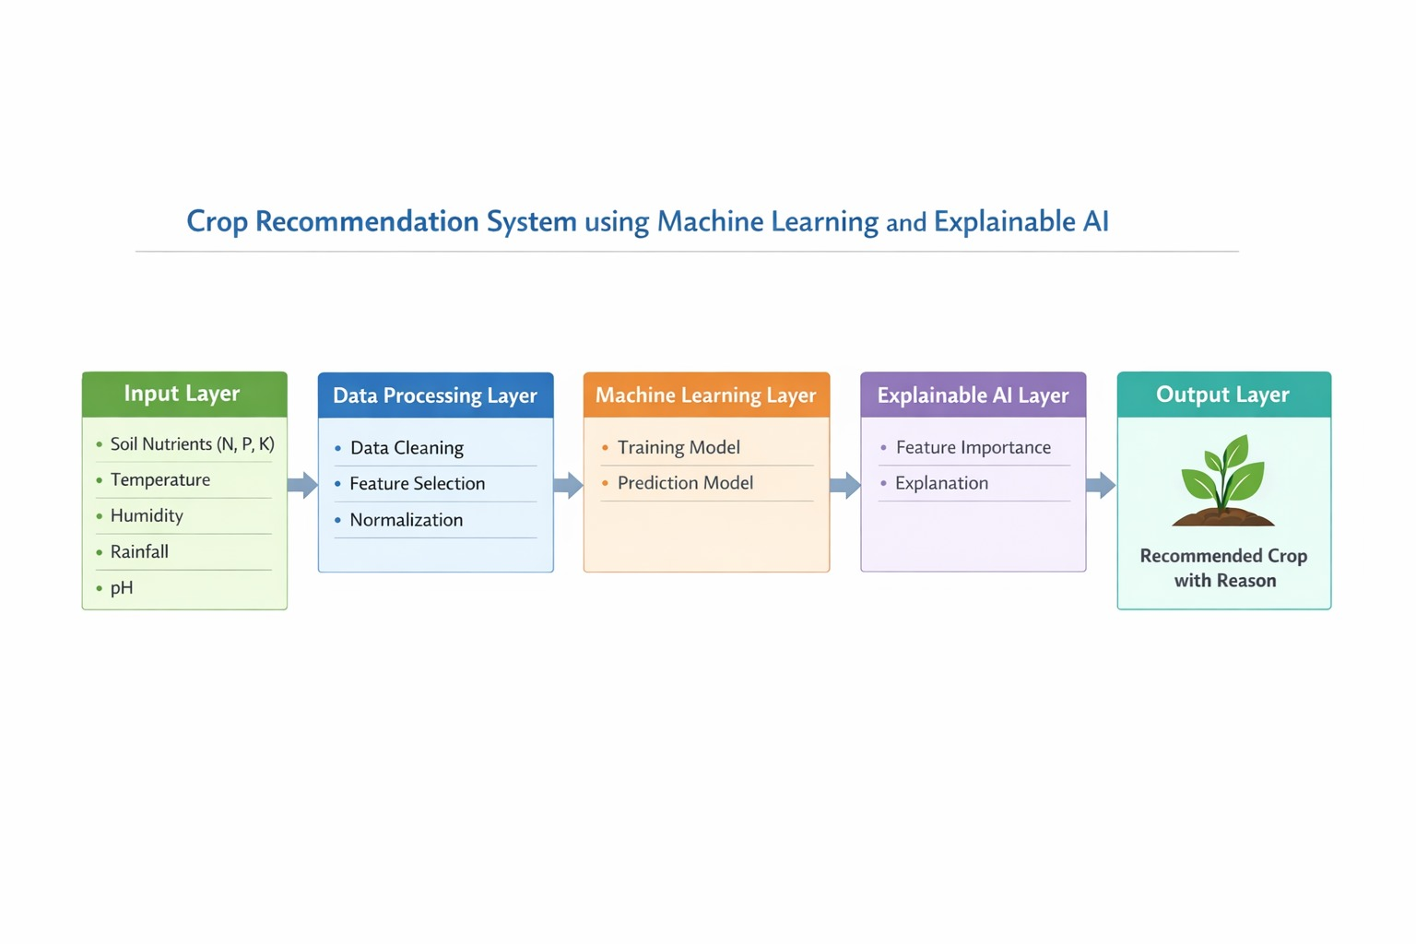Fig 2 : Solution diagram

The system architecture is designed using a three-layer structure consisting of the presentation layer, application layer, and data layer. The presentation layer represents the frontend interface where users interact with the system through web pages and dashboards. The application layer includes the backend APIs that process user requests and perform data analysis.

The data layer contains the election datasets that store information such as candidate names, party affiliations, vote counts, and election results. This layered architecture ensures efficient communication between system components and improves scalability.

Security and reliability are also considered in the proposed solution. Input validation techniques are used to ensure that user queries are processed safely and correctly. The system also performs data cleaning and validation to ensure that election datasets are consistent and free from errors before analysis. These measures help maintain the accuracy and reliability of the results displayed to users.

Another advantage of the system is its scalability and flexibility. The platform can easily be expanded to include additional election datasets, advanced analytical features, or predictive models in the future. For example, future versions of the system could include trend analysis, voter behavior predictions, or comparative analysis of election results across different years. Because the system is built using modular components, new features can be integrated without affecting the existing functionalities.

Overall, the proposed AI Election Analysis Platform provides a modern approach to analyzing election data by combining data processing, visualization, and artificial intelligence. The system simplifies the exploration of election results and helps users gain deeper insights into voting patterns and political trends. By transforming complex election datasets into interactive dashboards and AI-driven insights, the platform improves transparency, accessibility, and understanding of election information.

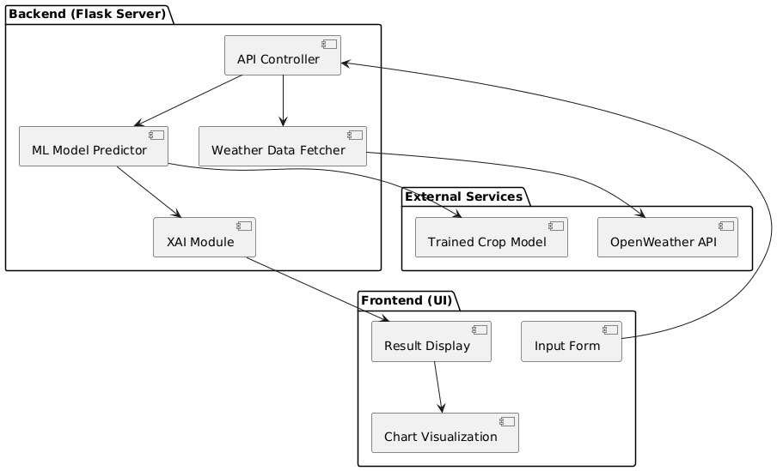
Fig 3: Architecture

The Explainable AI Based Crop and Organic Pest Recommendation System With Soil and Dynamic Weather Data is formulated in line with the three-layer architecture model, which ensures that it has a modular design, is easily maintained, and it processes the data with ease. The system architecture is further categorized into three primary layers which include Presentation Layer, Application Layer and Data Layer.

The Frontend UI (Presentation Layer) is the interface of the system that allows interactivity with the system via the components of the system i.e. the Input Form, Result Display and Chart Visualization. The form has user inputs which are sent to the backend to be processed. Presentation is presented in a structured way accompanied by graphical information such as charts, hence the system is user-friendly and easy to use. Web technologies are usually used to create this layer like HTML, CSS, and JavaScript in order to make this layer responsive and accessible.

The Application Layer (Backend - Flask Server) is the processing unit in the system. It is written in Python and based on the Flask framework and consists of such modules as the API Controller, ML Model Predictor, Weather Data Fetcher, and XAI (Explainable AI) Module. The API Controller manages the communication between the frontend and the backend and the ML Model Predictor makes the predictions with the help of trained models. The Weather Data Fetcher gathers external real-time information and the XAI module gives an explanation to the predictions, which makes it more transparent. This layer receives user requests and the calculated results are returned to the frontend.

The Data Layer is a set of third-party services and trained models that facilitate the functionality of the system. It will contain the resources like the trained crop prediction model and external APIs like weather services which would give the necessary data to enable precise prediction. This layer makes sure that there is access and integration of data that is reliable hence the system is effectively carried out. In general, user interaction, processing logic, and external data dependencies are separated in the three-layer architecture, which enhances its scalability, maintainability, and performance.

In general, the three-layer architecture enhances the scalability and performance of the system by isolating three parts, including user interaction, data processing, and data storage.

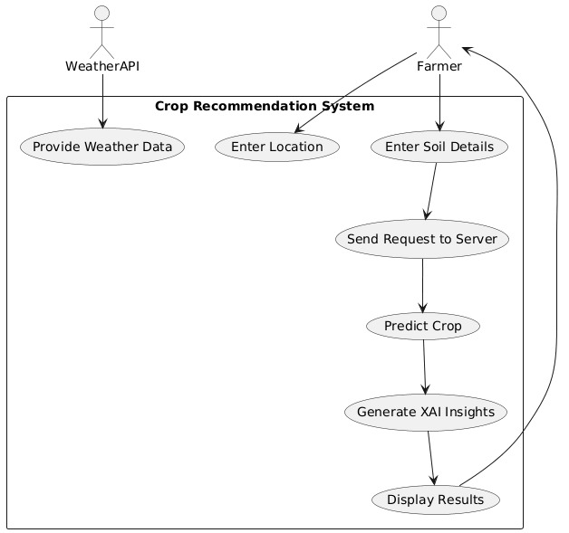
Fig 4: Data Flow Diagram

The Data Flow Diagram (DFD) of the Crop Recommendation System will show data flow within the system and this is beginning with the user input and culminates with the ultimate recommendation and insights provided to the farmer. It assists in learning how other components are interacting and the manner information is processed at every level. The system will have two key external components, the Farmer, which will be used to feed in the input data, and the Weather API, which will be used to provide real-time weather data that will need accurate predictions.

The process starts with the farmer keying in fundamental inputs to the system which includes location and soil information. Meanwhile, Weather API offers appropriate weather information. These input are subsequently joined and transmitted to the server as a request. This request is sent to the backend system which processes the request through the crop prediction model. According to the specified parameters, the system examines the data and forecasts the crop that is the most appropriate. Following the prediction, the Explainable AI (XAI) module develops insights to enhance the explanation of why a certain crop is suggested to enhance transparency and user confidence.

After the prediction and insights were generated, the results are returned to the user interface. The system shows the suggested crop and explanatory insights in a format that was easy to understand. This will make sure that not only will farmers get the correct recommendations but also an explanation of why it was recommended as such. In general, the DFD demonstrates the smooth flow of data to be collected, processed, predicted, and explained to final result visualization that will help to have an efficient and user-friendly system.
Therefore, as evidenced by the DFD, the flow of data between the user and the backend system and finally to the dataset and back to the user via visualization and analytical outputs is evident.

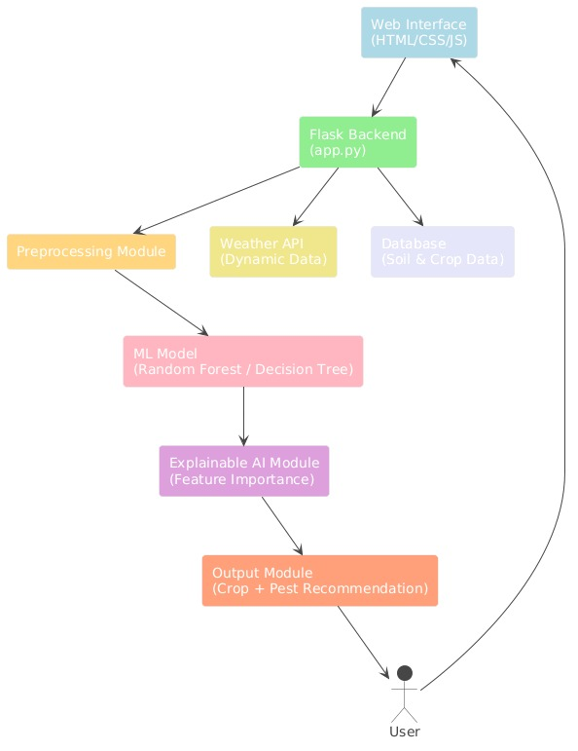
Fig 5: UML diagram

The UML Diagram of Crop Recommendation System reflects the interplay of the various components and the way the system responds to the user request in order to produce smart results. It assists in the appreciation of the working sequence of the system, beginning with the user interaction via web interface to the end result provided back to the user. The diagram shows the correlation between different modules used to obtain accurate recommendations on crop and pests.

The main interaction commences when the user opens the system via the web interface created based on HTML, Cascading Style sheets, and JavaScript. The user makes the required inputs like location and the details of the soil that are transmitted to the Flask backend (app.py). The backend is the main controller and is connected to several other components, such as the Weather API to obtain dynamic information about the environment and the database, which stores information about soil and crops. The data obtained before processing is subjected to the preprocessing module where the data is cleaned and made ready to be fed to the model.

The data is processed and afterwards sent into the machine learning model say, the random forest or decision tree, which then predicts the best crop. The Explainable AI module is the next module that analyses the prediction and gives feature importance to justify the reasoning behind the recommendation. Lastly, the output module produces the output such as crop and pest recommendations that are presented to the user in the interface. Therefore, the diagram also provides a clear picture of the entire workflow process, as it is clear how user inputs are processed into meaningful and explainable outputs using system-integrated components.

UML diagram assists developers in knowing how the system works, how to interact with the users, and the structure of their workflow. It also helps in model designing the system in a modular manner to enable more future possible features like predictive analytics or more election datasets to be introduced without interfering with current operations.

2.2 SIMULATION SETUP AND IMPLEMENTATION:

The implementation stage and simulation setup are devoted to the creation and testing of Crop Recommendation System based on the use of Machine Learning in a controlled environment to make sure that all system elements work properly. At this phase, the development environment should be configured, agricultural data should be integrated, the backend and frontend modules will be developed, and the system functionality can be verified by simulation. The idea is to make sure that the system is able to compute the agricultural parameters correctly and give appropriate crop recommendations to the users.

The proposed system was developed within frameworks and software which were easily available. The front part of the application was created with the help of HTML, Cascading Style Sheets, and JavaScript that contributes to the creation of an interactive web interface in which customers can input soil and environmental values. Python and Flask were used as the backend of the system, which enables it to develop APIs to handle user inputs and produce crop predictions. Python was chosen due to its close integration with machine learning and data analysis packages like Pandas, NumPy and Scikit-learn, which are performed on agricultural datasets and are used to train prediction models.

The simulation setup was installed in a local computer system through a standard development setup. The Flask Python server was deployed as the backend server and it provides a local webserver that takes to the user requests and input parameters. The frontend interface interacts with the backend via HTTP request to get the result of crop recommendations. The simulation used agricultural data was saved in structured files such as CSV or excel sheets where the data about the soil nutrients such as nitrogen, phosphorus, potassium, temperature, humidity, rainfall, and soil pH were saved. These datasets were pre-processed and cleaned and therefore incorporated into the system to achieve correct training and prediction of the models.

In the implementation stage, the machine learning modules were created, which read the agricultural data and provided crop recommendations to the user input. In case a user has to enter parameters into the frontend e.g. soil nutrients, temperature, humidity, rainfall and pH value then the frontend transmits this information to the backend server. The backend is used to analyze the input with a trained machine learning model that will recognize patterns in the dataset and determine the most appropriate crop to grow. The result is then predicted and sent back to the frontend interface and presented to the user in a clear and understandable form.

The Explainable Artificial Intelligence (XAI) techniques are also offered in the system to enhance transparency and understanding by the users. The system does not just give a crop prediction outcome, but offers a way in which the model came up with the recommendation. Highlighting of the key factors that affected the prediction can be accomplished using techniques like LIME (Local Interpretable Model-Agnostic Explanations), which indicates the nutrients of soil or the level of rainfall. This aids the users in getting a reasoning behind the recommendation and trust in the system.

Another part of the simulation carried out in the process was testing and validation to verify that the system is working properly. Different test conditions were made to test the system performance and accuracy. These tests involved the supply of varying ratios of soil and environmental parameters, checking of the accuracy of crop predictions, and checking of the system to deal with invalid or incomplete inputs. Another interface responsiveness and a stable back-end processing were also tested in the system.

Measuring performance was done to determine the efficiency of the system with regard to input data processing through to the production of recommendations. Because the agricultural databases might include numerous records, effective methods of data processing were used with Pandas and streamlined machine learning simulations. The optimizations contribute to less time of processing and prompt delivery of crop recommendations to users once they feed their input parameters.

The obtained results of the simulation allow concluding that the Crop Recommendation System based on the concept of Machine Learning can effectively process the soil and environmental parameters and produce the appropriate crop recommendations. The interface allows users to simply feed in input values where they receive credible recommendations depending on the trained machine learning model. Explainable AI also contributes to the increased usability and transparency of the system.

To sum up, the simulation environment and the execution thereof attest to the fact that the proposed system is functional within a controlled development environment. Through the integration of the modern web technologies, machine learning, and explainable AI techniques, the system can convert agricultural data into realistic recommendations that can assist farmers and agricultural researchers to make improved choices during crop selection and enhance agricultural productivity

CHAPTER-3

3.1 RESULT COMPARISON AND ANALYSIS:
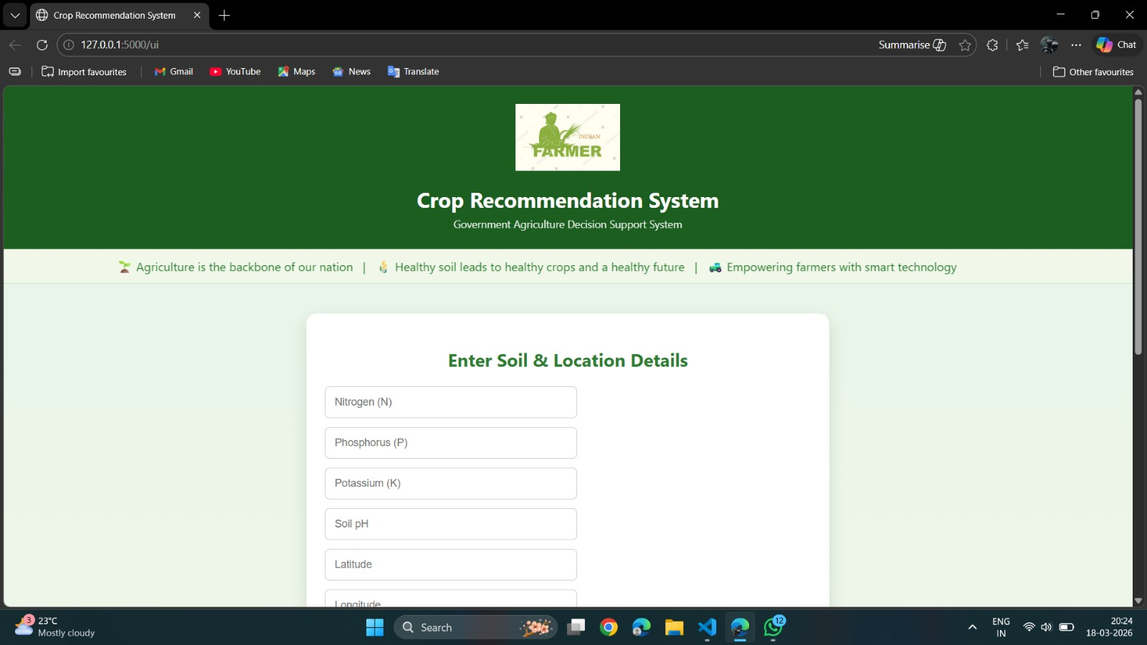

Fig6: Home Page
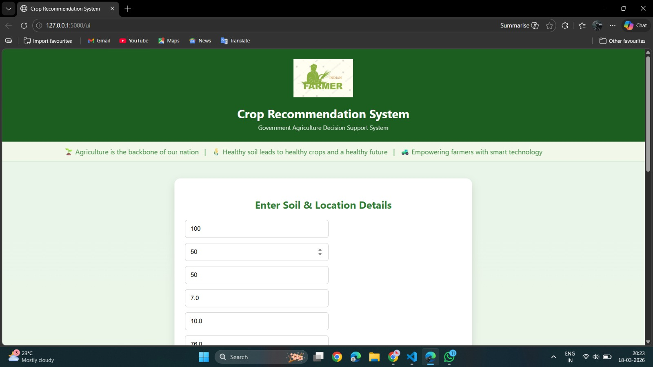
Fig7: User Input-1
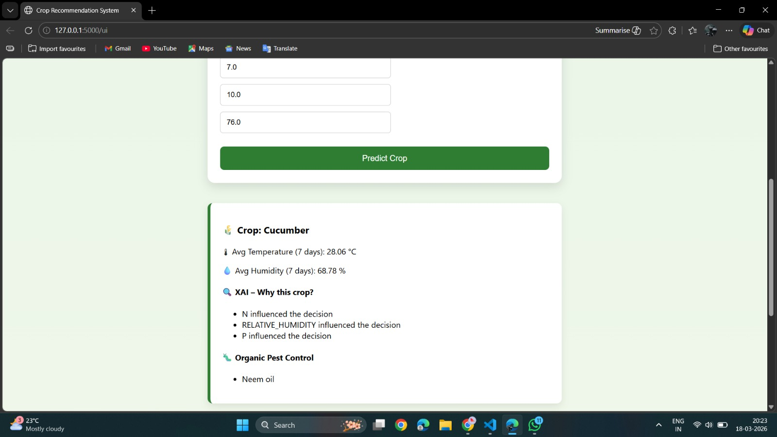
Fig8: Output

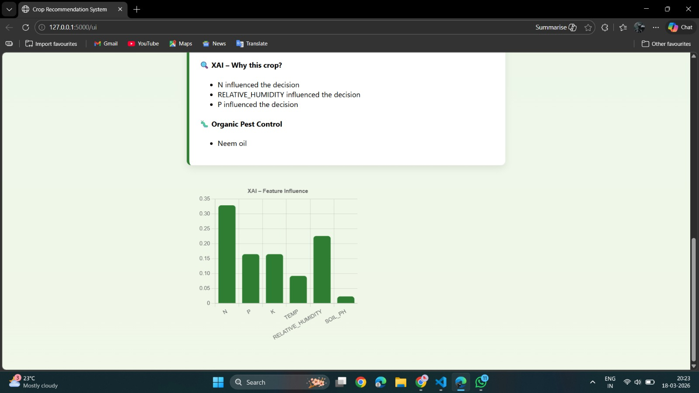
Fig9: Graph-1

Fig10: User Input-2
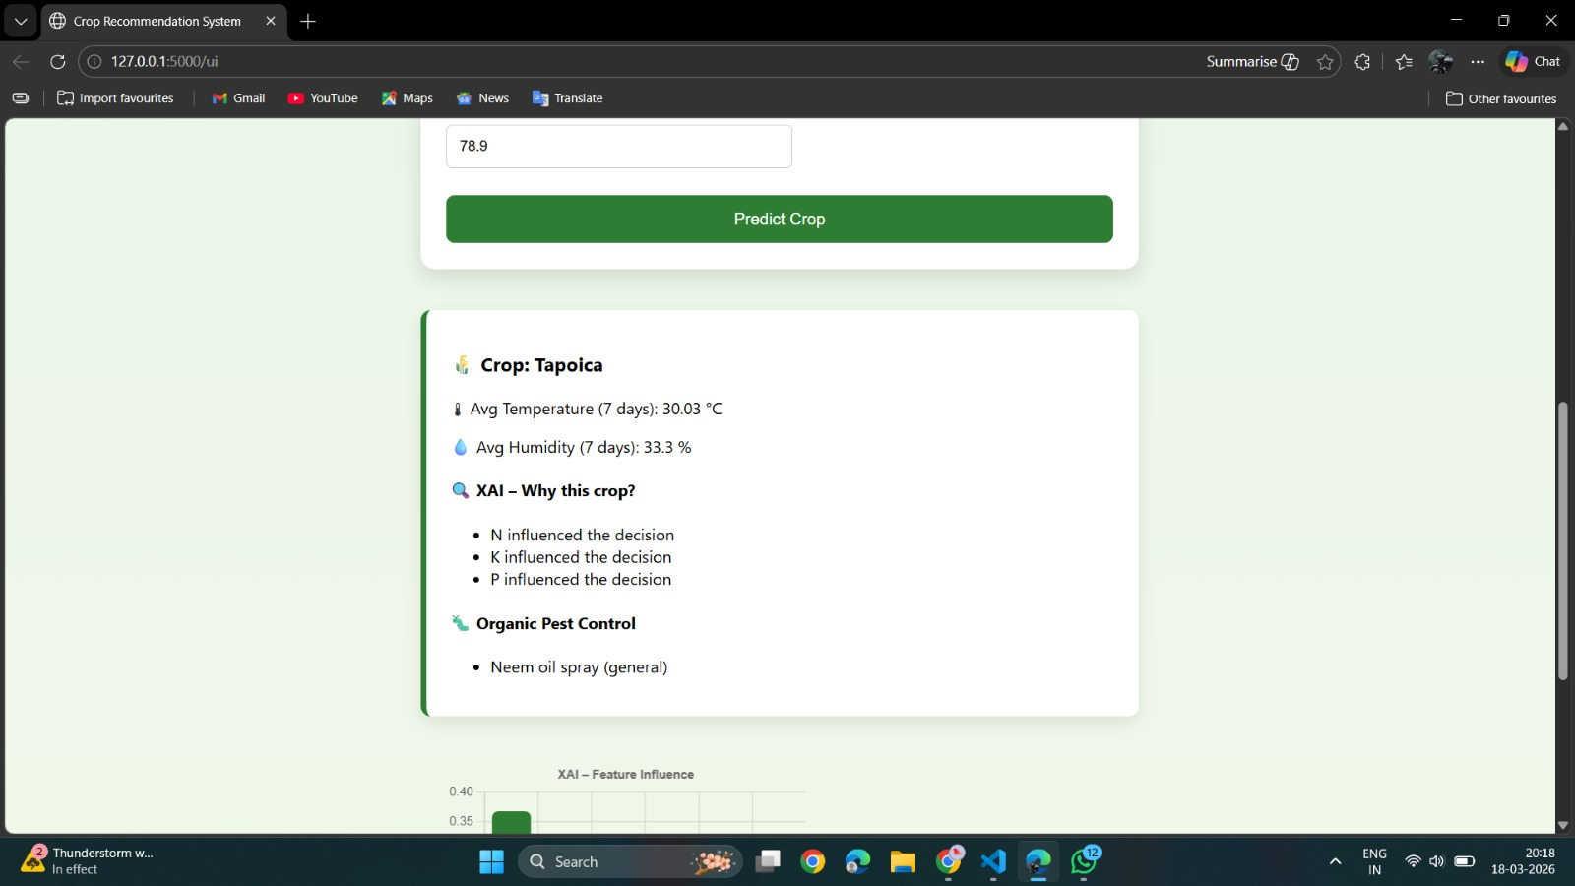
Fig11: Output-2
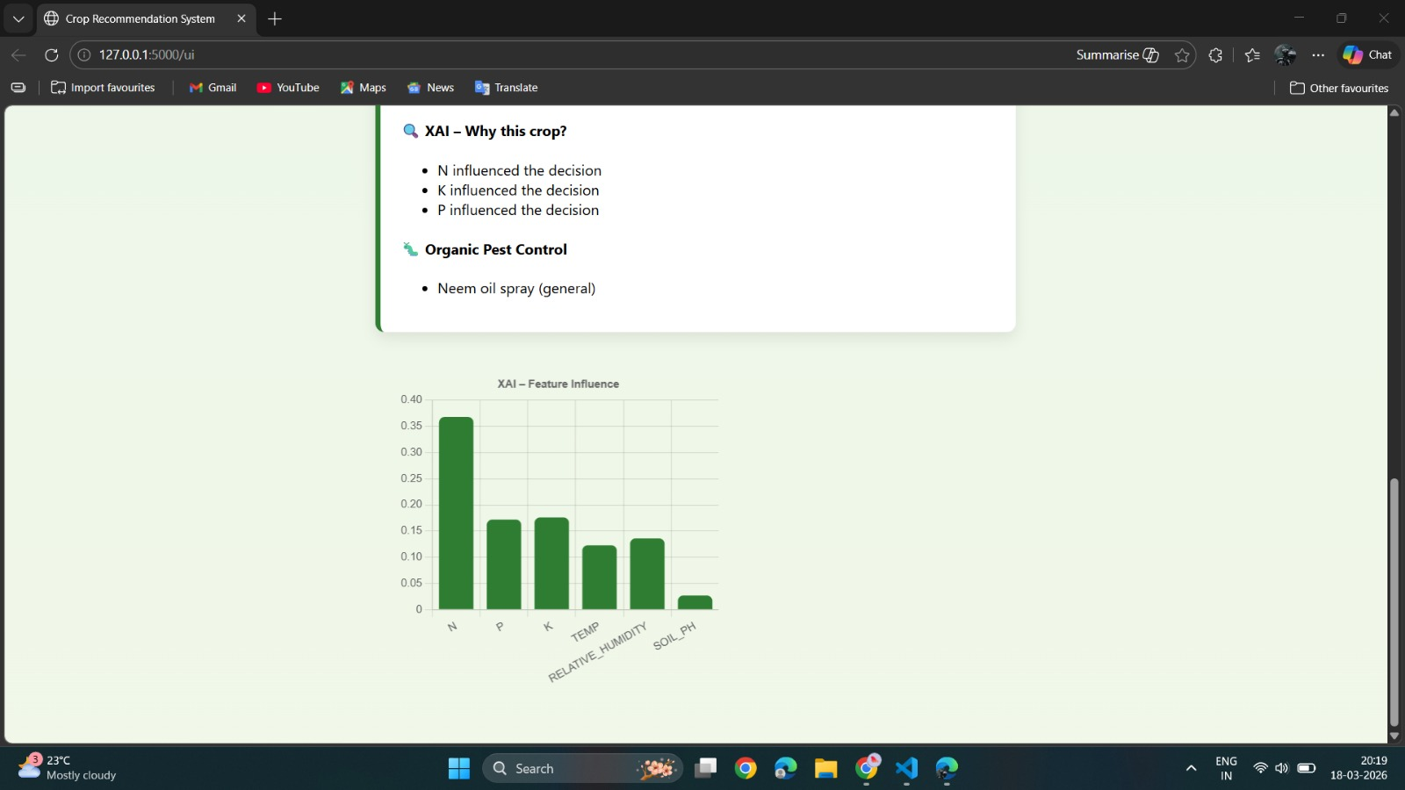
Fig12: Graph-2

3.2 LEARNING OUTCOME:
By coming up with the Explainable AI Based Crop & Organic Pest Recommendation
Using Soil and Dynamic Weather Data, we were able to get a detailed overview of how machine learning could be used to address the real-life agricultural issues. This project helped us to fill the gap between theory and practice through the work with the actual data concerning the nutrients of soil and environmental conditions. We gained a solid understanding of methods of preprocessing data, such as data cleaning, missing value treatment, and dataset preparation to be used as input to machine learning models. We also came to know how to choose the appropriate characteristics that include nitrogen (N), phosphorus (P), potassium (K), soil pH and geographical variables that are instrumental in the precise prediction of crops.

Through the project, we learnt and applied the classification algorithms such as Decision Tree and Random Forest. We had a practical experience on how to train models, adjust parameters and determine performance using the right metrics. This enhanced the capability to select the appropriate algorithms according to the problem environment.

Another important outcome of learning was the aspect of troubleshooting and debugging. Environment set-up problems, library dependencies, and version problems were also issues that we had to deal with during the project. These problems assisted us in acquiring the technical knowledge and gave us the courage to handle the developmental problems in life.

Furthermore, this project sensitized us more about the use of technology to realize sustainable agriculture. We acknowledged the importance of utilizing data to support decisions in improving the output of crops, risk reduction and assisting farmers to make sound decisions on the type of crops to cultivate based on scientific data. On the whole, the project made our understanding of machine learning, web development, system integration more robust, and enhanced the quality of our analytical thinking, problem-solving skills, and collaboration. It has equipped us with more complex projects and real time implementations in future.

3.3 CONCLUSION:

The Explainable AI Based Crop & Organic Pest Recommendation System Using Soil and Dynamic Weather Data produced within the current project is the illustration of the successful harmonization of machine learning methods with agricultural data to facilitate intelligent decision-making. The system forecasts the best crop to grow by examining the key soil nutrients including nitrogen (N), phosphorus (P), and potassium (K) and other environmental variables like pH of the soil and geographical location (latitude and longitude). Application of machine learning algorithms like Decision Tree and Random Forest can allow the system to understand the patterns of past agricultural data and give a precise recommendation on the crops. The models contribute to the analysis of complicated relations between the state of the soil and crop yielding that could not be analyzed manually.

The project also has a friendly web interface that was created with Flask and thus it is not only accessible to non-technical individuals. The farmers or users need to just key in the necessary parameters and get instant recommendations hence save time and effort. This improves usability and makes sure that the system can be applied practically on the real-world situation. Among the significant benefits of this system, one can distinguish the elimination of uncertainty in crop selection in favour, the reduction of the risk of crop failure, and enhanced agricultural productivity on the whole. The system also leads to sustainable agriculture and the effective use of resources because it encourages the use of data-driven farming practices.

Nevertheless, there are some limitations of the system, as well. It is sensitive to the quality and the accuracy of the dataset that is used in training. Also, the environmental conditions might change dynamically and this model might need periodic updates and retraining as time goes by to ensure that the accuracy of the model remains intact. To sum up, Crop Recommendation System is a dependable, effective and scalable solution in the current-day agriculture. It shows how artificial intelligence could change the farming practices of the past to smart and precision-focused farming, which would then benefit the farmers, boost crop production, and help to sustain the agricultural economy.

3.4 REFERENCES:
1) Ngugi, H.N., Ezugwu, A.E., Akinyelu, A.A. et al. Revolutionizing crop disease detection with computational deep learning: a comprehensive review. Environ Monit Assess 196, 302 (2024). https://doi.org/10.1007/s10661-024-12454-z

2) Musanase, C.; Vodacek, A.; Hanyurwimfura, D.; Uwitonze, A.; Kabandana, I. Data-Driven Analysis and Machine Learning-Based Crop and Fertilizer Recommendation System for Revolutionizing Farming Practices. Agriculture 2023, 13, 2141.
https://doi.org/10.3390/ agriculture13112141
3) Ali, Z.; Muhammad, A.; Lee, N.; Waqar, M.; Lee, S.W. Artificial Intelligence for Sustainable Agriculture: AComprehensive Review of AI-Driven Technologies in Crop Production. Sustainability 2025, 17, 2281. https://doi.org/10.3390/ su17052281
4) Singh,K.; Yadav,M.;Barak, D.; Bansal, S.; Moreira, F. Machine-Learning-Based Frameworks for Reliable and Sustainable Crop Forecasting. Sustainability 2025, 17, 4711.
https://doi.org/10.3390/ su17104711
5) Rani, S., Mishra, A.K., Kataria, A. et al. Machine learning-based optimal crop selection system in smart agriculture. Sci Rep 13, 15997 (2023).
https://doi.org/10.1038/s41598-023-42356-y
6) Shams, M.Y., Gamel, S.A. & Talaat, F.M. Enhancing crop recommendation systems with explainable artificial intelligence: a study on agricultural decision-making. Neural Comput & Applic 36, 5695–5714 (2024).
https://doi.org/10.1007/s00521-023-09391-2

LINKS

Video Presentation: https://youtu.be/y4lsEqPA87k?si=ayOkQLOJXHePWF7i

Linkedin: https://www.linkedin.com/posts/vadije-vishishta-1664a2290_majorproject-machinelearning-aiinagriculture-activity-7432637838417952768-LHNE?utm_source=share&utm_medium=member_desktop&rcm=ACoAAEaNKF4BjnIEqCvpf8z7rxViT3Dq754vgE4

Github: https://github.com/Pakaneha/Crop-Recommendation

Blog: https://medium.com/@2203a52232/explainable-ai-based-crop-organic-pest-recommendation-system-using-soil-and-dynamic-weather-data-8f7b6badbbd5

